Ref. No: CHEM/0013 Date: 09/09/2023.

Notice Regarding class suspension
It is hereby notified to all students of 1st Semester Chemistry major and minor, 2nd semester Hons, Programme and GE that departmental classes (only chemistry, not other subject) will be suspended from 16/09/2023 to 19/09/2023 due to upcoming 4th semester Hons practical examination.
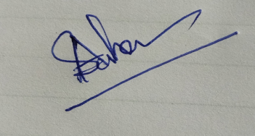
HOD
Department of Chemistry

